
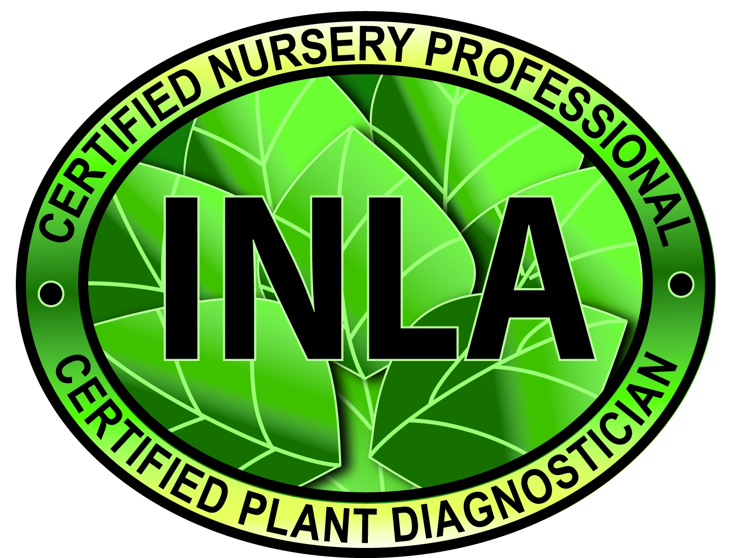

Idaho Nursery & Landscape Association
Certified Nursery Professional &
Certified Plant Diagnostician
Test Application

Date of Application___________________

Applicant’s Name______________________________________________________________

Home Address_________________________________________________________________

City________________________________________State_____________Zip______________

Email: _____________________________Home telephone________________________________

Number of years worked in industry _____________________

Currently employed at ________________________________________

Local newspaper you would like contacted upon passing____________________________

Please choose from below and mark the correct testing fee

CNP Exam
□ INLA member (1st time, includes written and plant ID) $50.00
□ INLA non-member $100.00
□ (2nd attempt written or plant id) $25.00

CPD Exam Fee*
□ INLA member $35.00
□ Non-member $75.00

*MUST have passed Certified Nursery Professional exam

Total enclosed (or paid with credit card) _____________

Credit card number
Expires

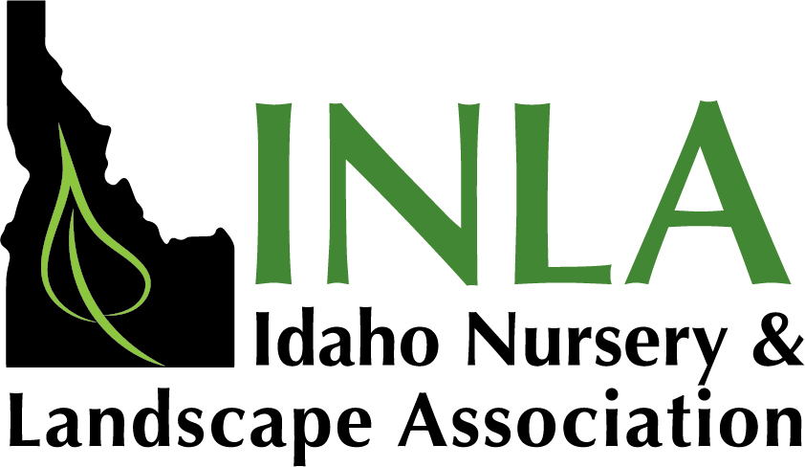
Mail completed application and send with check to:
Idaho Nursery & Landscape Association
P. O. Box 2065
Idaho Falls, ID 83403 or fax to (208) 529-0832

Official training manuals for each exam can be acquired through the office by calling 208-681-4769.

FOR OFFICE USE ONLY

Amount paid__________________ Check #_____________________________

Written Test Score_________________________ Plant ID Score _____________________Certification No._____________________

