Will you help advance horticulture education?

INLA Education & Scholarship Donation Form

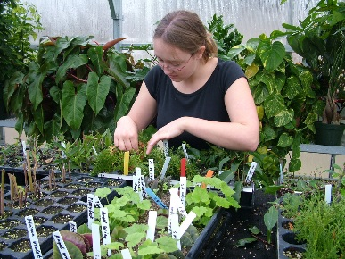
The Idaho Nursery & Landscape Association has a scholarship program to assist horticulture students with their education. The funds raised through our auction held during the Idaho Horticulture Expo also assist us in promoting certification and programs for industry employees.

We are requesting a donation from you for our auction.

________________________________________________________
Donor/Company Name

________________________________________________________
Item

_____________________________
Retail Value

Your assistance in raising funds for these important
programs is greatly appreciated!

Please bring form and donation to the Idaho Horticulture Expo
or mail form to:

INLA Education Donations
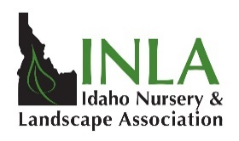
PO Box 2065
Idaho Falls, ID 83403
or
Fax to: 208-529-0832

Thank you for the support!

